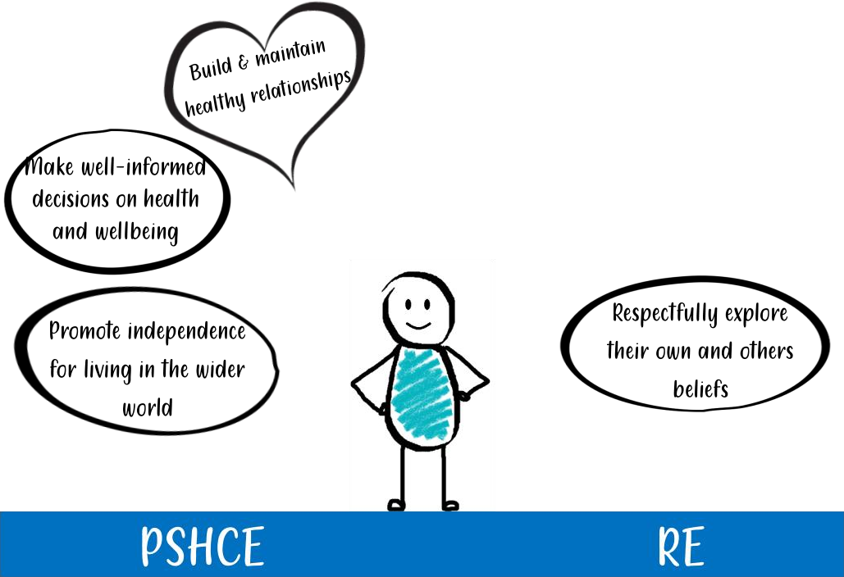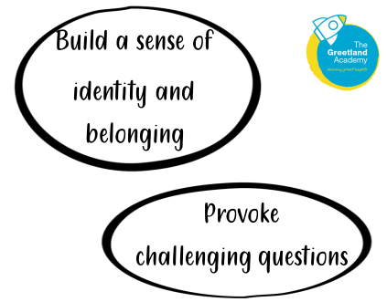

We are preparing our learners to be able to flourish and thrive with the opportunities, responsibilities and experiences of life in modern day Britain.

We are preparing our learners to explore what people believe and what difference this makes to how they live, so that our learners can gain the knowledge, understanding and skills needed to handle questions raised by religion and belief, reflecting on their own ideas and ways of living.