Theme/Term | Autumn 1 |  |  |  |  |  | Autumn 2  Cycle A
Writing Root/  Spelling Seed Text | 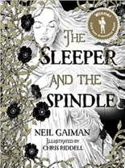  The Sleeper and the Spindle  Neil Gaiman and Chris Riddell |  | 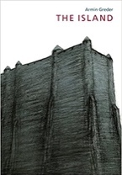  The Island  Armin Greder |  |  | Science: Space | 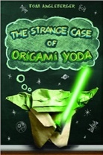  Origami Yoda  Tom Angleberger |  | 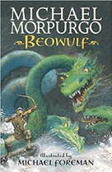  Beowulf  Michael Morpurgo
Length | 17 sessions, 3+ weeks |  | 15 sessions, 3+ weeks |  |  |  | 15 sessions, 3 weeks |  | 15 sessions, 3 weeks
Outcomes | Fairytale reworkings  Warning posters, diaries, dialogue, descriptions, missing narratives |  | Sequel  Welcome guide, description, letter of advice, diary entry in role, imagined conversation |  |  |  | Discussion texts  Instructions, persuasion, diaries |  | Own version legends Letters of advice, diaries, dialogue, descriptions, action scenes, obituaries
Literary Leaf Text | 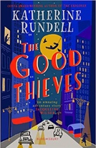  The Good Thieves  Katherine Rundell |  |  |  | 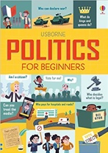  Politics for Beginners  Louie Stowell |  | 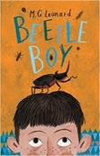  Beetle Boy  M. G. Leonard |  | 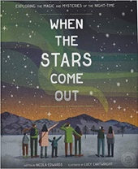  When the Stars Come Out  Nicola Edwards
Length | 15 sessions, 3 weeks |  |  |  | 15 sessions, 3 weeks |  | 15 sessions, 3 weeks |  | 12 sessions, 3 weeks
Theme/Term | Spring 1 |  |  |  |  |  | Spring 2
Writing Root/  Spelling Seed Text | 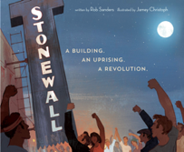  Stonewall  Rob Sanders & Jamey Christoph |  |  | 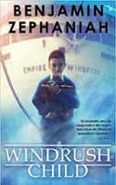  Windrush Child  Benjamin Zephaniah |  |  | 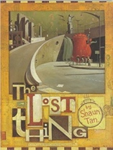  The Lost Thing  Shaun Tan |  |  | 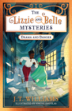  The Lizzie and Belle Mysteries  J.T. Williams
Length | 15 sessions, 3 weeks |  |  | 15 sessions, 3 weeks |  |  | 16 sessions, 3+ weeks
Outcomes | A visitor’s guide  Adverts, short news reports, protest banners, writing in role |  |  | Persuasive pitches  Thought bubbles, informal letters, poems, diary entries, advice, informal letters |  |  | Own version narratives  Diaries, formal letters, adverts, character and setting descriptions, reports |  |  | Biographies Posters, diary entries, case notes, letters, character descriptions, fact files, persuasive speeches
Literary Leaf Text | 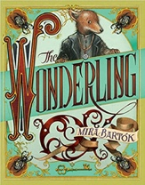  The Wonderling  Mira Bartok |  |  |  | 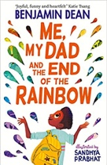  Me, My Dad and the End of the Rainbow  Benjamin Dean |  | 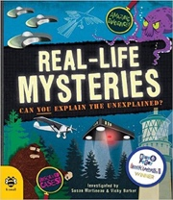  Real-life Mysteries: Can you explain the unexplained?  Susan Martineau and Vicky Barker |  | 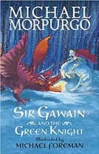  Sir Gawain and the Green Knight  Michael Morpurgo
Length | 15 sessions, 3 weeks |  |  |  | 15 sessions, 3 weeks |  | 15 sessions, 3 weeks |  | 20 sessions, 4 weeks
Theme/Term | Summer 1 |  |  |  |  |  | Solving mysteries Summer 2
Writing Root/  Spelling Seed Text |   Robot Girl  Malorie Blackman |  | Boy in the Tower  Polly Ho-Yen  15 sessions, 3 weeks  Own version narratives (past and present tense)  Journalistic writing, formal letters, non-chronological reports |  |  |  | 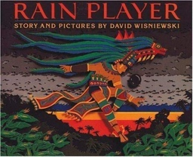 | Rain Player  David Wisniewski |  | 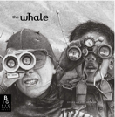 | The Whale  Ethan & Vita Murrow
Length | 15 sessions, 3 weeks |  | 15 sessions, 3 weeks |  |  |  | 15 sessions, 3 weeks |  |  | 15 sessions, 3 weeks
Outcomes | Science-fiction narratives  Discussions, debates, dialogue, character comparisons, reviews |  | Own version narratives (past and present tense)  Journalistic writing, formal letters, non-chronological reports |  |  |  | Analytical essays about The Maya  Instructions, posters, missing scenes, diaries, newspapers, debates |  |  | Film pitches Reported speeches, speech and thought bubbles, descriptions, recounts in role, letters to a newspaper editor
Literary Leaf Text | 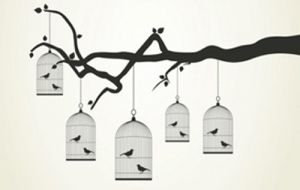  Caged Bird  Maya Angelou |  | 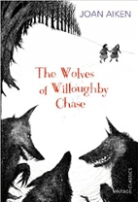  The Wolves of Willoughby Chase  Joan Aiken |  |  |  | 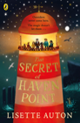  The Secret of Haven Point  Lisette Auton |  |  | 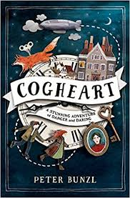  Cogheart  Peter Bunzl
Length | 10 sessions, 2 weeks |  | 15 sessions, 3 weeks |  |  |  | 17 sessions, 3+ weeks |  |  | 16 sessions, 3+ weeks

