Theme/Term | Autumn 1 |  |  | Autumn 2  Cycle A
Writing Root/  Spelling Seed Text | 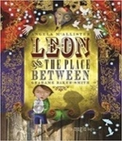  Leon and the Place Between  Angela McAllister | 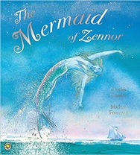  The Mermaid of Zennor  Charles Causley |  | 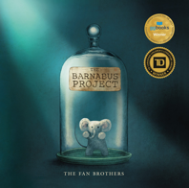  OR The Barnabus Project  The Fan Brothers | 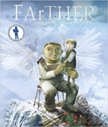  FArTHER  Grahame Baker Smith
Length | 15 sessions, 3 weeks | 15 sessions, 3 weeks |  | 15 sessions, 3 weeks | 15 sessions, 3 weeks
Outcomes | Own version fantasy narratives  Persuasive posters, setting descriptions, thought bubbles/diaries, dialogue | Own version legends  Information booklets, retelling from a different perspective, letters, tourist guides updates, dialogue |  | Brochures  Instructional writing (escape plan, experiment), descriptions, advertisements, letters of advice, dialogue | Sequel stories  Retellings, recounts (postcards), setting descriptions, diary entries, instructions
Literary Leaf Text | 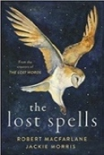  The Lost Spells  Robert MacFarlane |  | Earth Shattering Events  Robin Jacobs  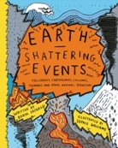  Geography Link | 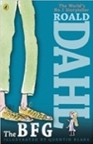  The BFG  Roald Dahl | 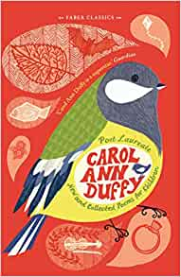  New and Collected Poems for Children  Carol Ann Duffy
Length | 10 sessions, 2 weeks |  | 15 sessions, 3 weeks | 15 Sessions, 3 weeks | 10 Sessions, 2 weeks
Theme/Term | Hope & healing Spring 1 |  |  | Overcoming adversity Spring 2
Writing Root/  Spelling Seed Text | 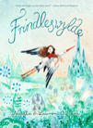  Frindleswylde  Natalia O’Hara & Lauren O’Hara | 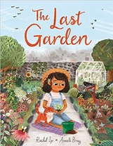  The Last Garden  Rachel Ip |  | 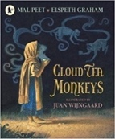  Cloud Tea Monkeys  Mal Peet | 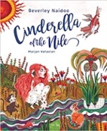  Cinderella of the Nile  Beverley Naidoo
Length | 16 sessions, 3+ weeks | 15 Sessions, 3 weeks |  | 15 sessions, 3 weeks | 15 sessions, 3 weeks
Outcomes | Narrative sequels  Letters, voting slips, dialogue, poetry, birds-eye view descriptions, speeches | Own version extended narrative  Setting descriptions, advertisement/ poster, retelling, instructional flyer, social media updates, dialogue |  | Non-chronological reports  Descriptions, ‘how to’ guides (instructions), letters, discussions | Own version narratives  Descriptive passages, how to guides, letters, discussions, non-chronological reports
Literary Leaf Text | 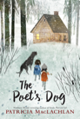  The Poet’s Dog  Patricia MacLachlan | 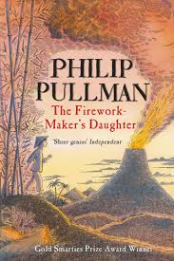  The Firework Maker's Daughter  Philip Pullman |  | 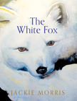  The White Fox  Jackie Morris |   Africa, Amazing Africa  Atinuke
Length | 15 Sessions, 3 weeks | 14 sessions, 2+ weeks |  | 15 Sessions, 3 weeks | 15 sessions, 3 weeks
Theme/Term | From mystery to discovery Summer 1 |  |  | Pride & downfall Summer 2
Writing Root/  Spelling Seed Text | 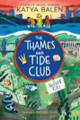  The Thames and Tide Club  Katya Balen | Pride: The Story of Harvey Milk and the Rainbow Flag  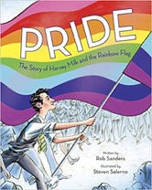  Rob Sanders |  | 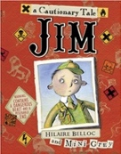  Jim, A Cautionary Tale  Hilaire Belloc | 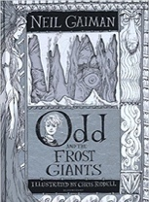  Odd and the Frost Giants  Neil Gaiman  History:  Vikings
Length | 15 sessions, 3 weeks | 15 sessions, 3 weeks |  | 15 sessions, 3 weeks | 15 sessions, 3 weeks
Outcomes | Own version fantasy narrative Persuasive letters and letters of advice, diary entries, weather reports, advertisements, dialogue | Biographies of Harvey Milk  Thought bubbles, speech, simple leaflets |  | Narrative poems  Warning posters, warning announcements, alternative endings, performance poetry, letters of apology | Retellings - alternative perspective  Narrative recounts, character and setting descriptions, letters, short explanations
Literary Leaf Text | 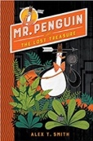  Mr Penguin and the Lost Treasure  Alex T. Smith |  | 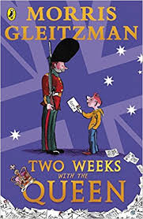  Two Weeks with the Queen  Morris Gleitzman | I am the Seed that Grew the Tree  Fiona Waters  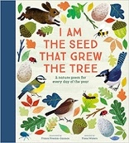  Science: Plants | 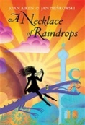  A Necklace of Raindrops  Joan Aiken
Length | 15 sessions, 3 weeks |  | 16 Sessions, 3+ weeks

