Theme/Term | Autumn 1 |  |  | Autumn 2
Writing Root/  Spelling Seed Text | 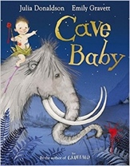  Cave Baby  Julia Donaldson and Emily Gravett |  | 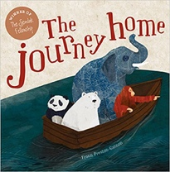  The Journey Home  Frann Preston-Gannon  Science: Conservation | 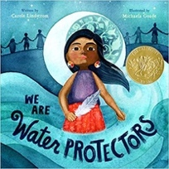  We Are Water Protectors Carole Lindstrom |  | 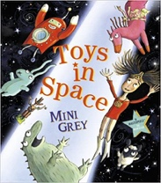  Toys in Space  Mini Grey
Length | 10+ sessions, 2+ weeks |  | 15 sessions, 3 weeks | 15 sessions, 3 weeks |  | 15 sessions, 3 weeks
Outcomes | Narrative retellings  Labels and captions, informal letters |  | Persuasive letters  Posters, lists, postcards, wanted posters, information reports, short stories | Environmental campaign  List poems, non-chronological reports (animals), chron reports (life- cycles), character description, protest signs |  | Own fantasy world narrative  Found posters, diary entries, speech bubbles, notes of advice, space logs, invitations, fantasy setting descriptions
Theme/Term | Similarities & differences Spring 1 |  |  | Spring 2
Writing Root /  Spelling Seed Text | 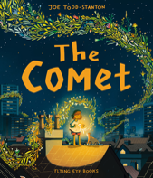  The Comet  Joe Todd-Stanton | 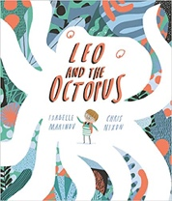  Leo and the Octopus  Isabelle Marinov |  |   The Owl and the Pussy-cat  Edward Lear |  |  | 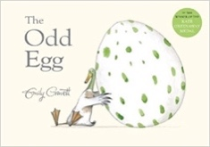  The Odd Egg  Emily Gravett |  | 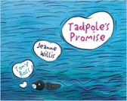  Science: Lifec ycles  Tadpole’s Promise  Jeanne Willis
Length | 15 sessions, 3 weeks | 15 sessions, 3 weeks |  | 10 sessions, 2 weeks |  |  | 10 sessions, 2 weeks |  | 15 sessions, 3 weeks
Outcomes | Own version narrative  Posters, letters of advice, poem, description, writing in role, recipes | Fact file  This is Me! posters, letters of advice, factual descriptions, logbooks, scripts |  | Rhyming poems  Letters, interviews, lists, instructions |  |  | Egg-spotter’s guides (non-fiction reports)  Thought and speech bubbles, diaries, letters, certificates |  | Own version narratives  Simple explanations, speech and thought bubbles, setting descriptions, extended explanations
Theme/Term | Fantasy journeys Summer 1 |  |  | Structures & materials Summer 2
Writing Root /  Spelling Seed Text | 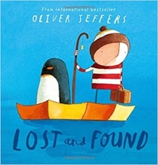  Lost and Found  Oliver Jeffers |  | 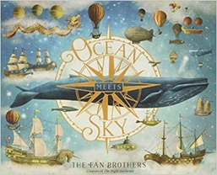  Ocean Meets Sky  Eric Fan and Terry Fan |  | 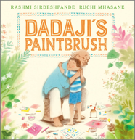  Dadaji’s Paintbrush  Rashmi Sirdeshpande |  |  | 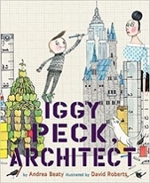  Iggy Peck, Architect  Andrea Beaty & David Roberts
Length | 15 sessions, 3 weeks |  | 15 sessions, 3 weeks |  | 15 sessions, 3 weeks |  |  | 15 sessions, 3 weeks
Outcomes | Own version ‘losing/finding’ narratives  Character descriptions, retellings, advice, instructions, non-chronological reports |  | Own version fantasy world narratives  Setting & character descriptions, labels, diaries, postcards, captain’s logs, instructions, dialogue |  | Own version narrative  Labels, captions, character comparisons, thought and speech bubbles, fact files |  |  | Fact files  Labels, character comparisons, character descriptions, building descriptions, posters

